Ticket Option Summer Winter  Adult £15.00 £10.00  Child £7.00 £5.00  Infant (0-4) £3.00 £3.00  Family of 4 £45.00 £40.00  31 Animal Zoo Road, Belfast  BT42M20  0281234567  bestchildrenszoo@gmail.com  Come and have fun at this amazing zoo!  See all the different types of animals.  This zoo has a play park and sand area for children and infants.  Check out the feeding times for each animal and watch the zoo keepers feed them and learn what type of food they eat.  Go to the gift shop on your way out and see all our teddys and toys. |  | 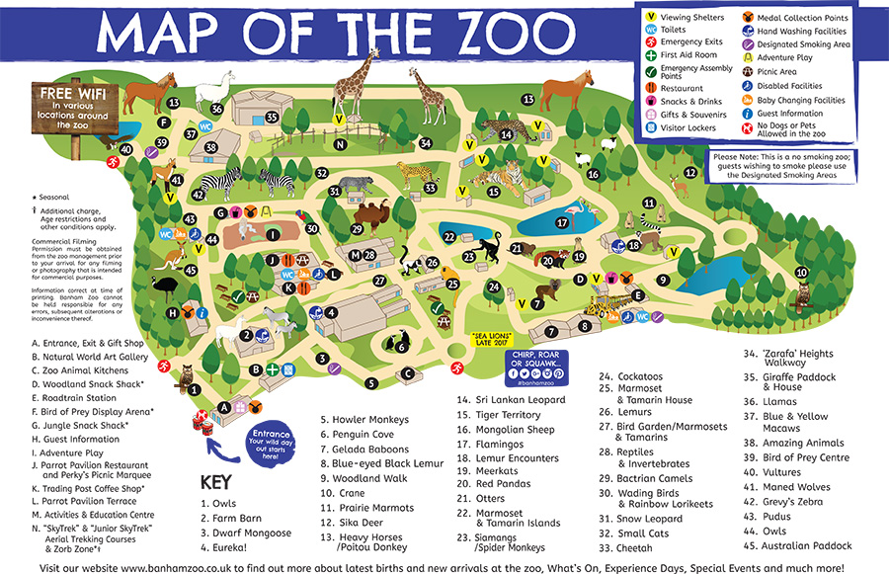 |  |  | Welcome to David Attenborough Children’s Zoo  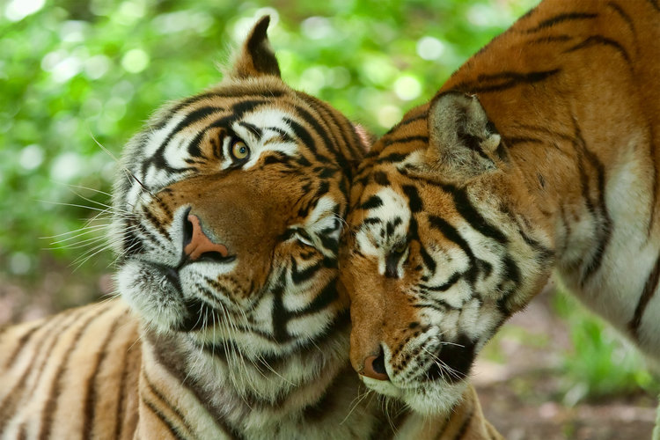  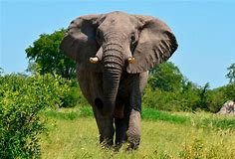  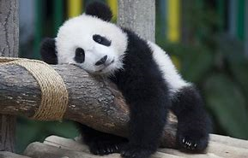

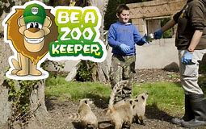  Become a junior zoo keeper for the day!  Explore the day in the life of a zoo keeper. Enjoy washing or feeding some of the animals, getting your picture taken, a guided tour of the zoo, a goodie bag and a certificate.  This is a brilliant day out for children.  This will cost £125.00. | What to do at the zoo!  The zoo has many animals including  - Monkeys  - Giraffes and zebras  - Lizards  - Elephants  - Lions  And many more!  Travel around the zoo in style for £10.00  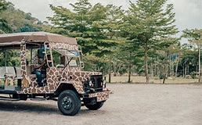 | 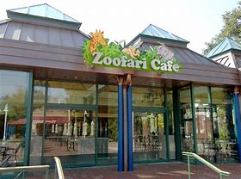  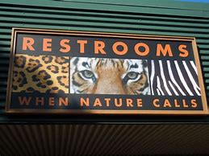  You can find our toilets and baby changing area on the zoo map!  We hope to you enjoy your visit!  Our zoo has a great cafe. You can buy delicious lunch here, cold ice lollys, coffee and much more at the zoofari café. enjoy the view whilst eating your lunch.

