Come and visit us at the brand new Sir David Attenborough Zoo!
We have a variety of animals and lots of activities for the whole family!
You can get close to the animals and see them in the wild! You might even get to feed a giraffe his l

We also have many cafes and restaurants as well as picnic areas for you to eat in!

We are close to Legoland at Windsor – make one trip to visit 2 great attractions!
Admission Prices
Ticket Type | Summer | Winter
Adult | £16.50 | £14.00
Child | £12.00 | £9.00
Child  (0-4) | Free | Free
Family Pass | £52.00 | £45.00
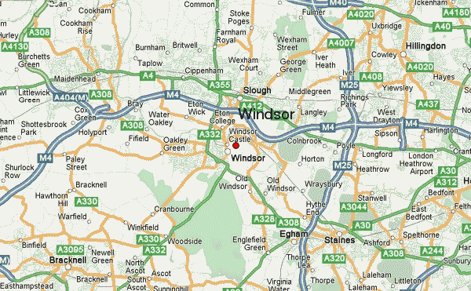
206 Wildflower Road,
Windsor,
SL24 3AA
Tel: 01754 333444
Email: info@dazoo.co.uk
Website: www.dazoo.co.uk
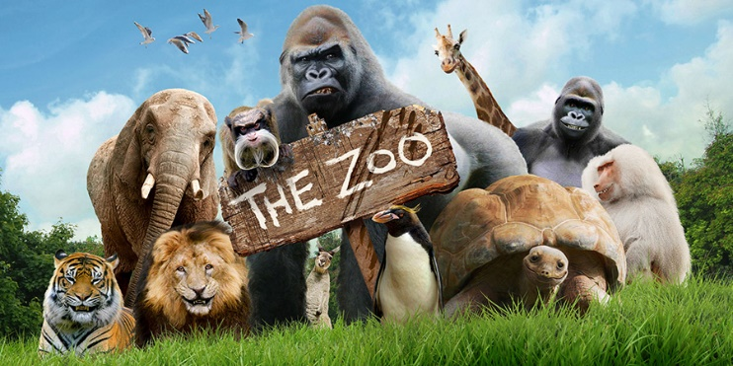

Welcome to the Sir David Attenborough Children’s Zoo!

“I really enjoyed our day out at the Sir David Attenborough Zoo. There were lots of animals and we got to see them up close. My favourite were the lions and tigers” Emily, age 8.

“Great fun – I can’t wait to go back to see the sealions again” Ben, age 12.

