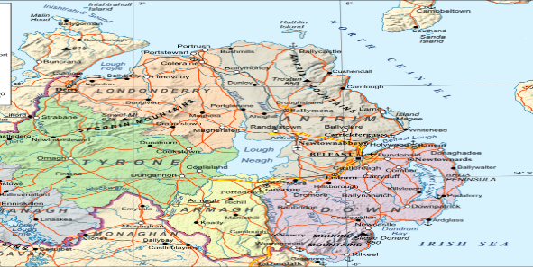
Sir David Attenborough

Children’s Zoo
Conservation

Our 55-acre site in County Tyrone Northern Ireland is home to more than 120 species, the majority of which are facing increasing danger in their natural habitats.
We take part in global and collaborative breeding programmes, which help to ensure the survival of many species under threat.
Your visitor experience
We work hard to provide a truly great day out for all of our visitors which is why Sir David Attenborough Zoo is one of Northern Ireland’s newest popular visitor attractions.

We’re an energetic zoo, passionate about education, learning and discovery. Our aim is to educate visitors about our animals and nature in general, and to provide you with a memorable experience.
We aim to:
- provide the best possible care for our animals
- organise campaigns and raise funds for endangered species and their natural habitats

Sir David Attenborough Children’s Zoo
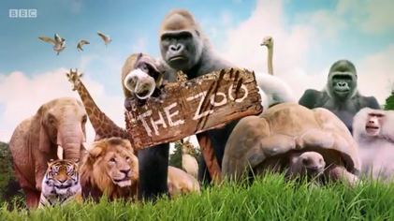

Main Road
Moygashel
Dungannon
County Tyrone
Tel: No: 028 3953 3961
Email: attenboroughzoo@global.com

Entry Costs:
Ticket Option | Summer | Winter
Adult | £8.00 | £7.00
Child | £5.00 | £4.00
Senior | £5.00 | £4.00
Infant(0-4) | £3.50 | £3.50
Family of 4 | £20.00 | £18.00

WELCOME to
THE SIR DAVID ATTENBOROUGH
CHILDRENS ZOO

Fantastic Zoo…really enjoyed our time here, we will be back
Clare Smith 36

SPECIAL OPENING EVENT !!!
Events over the Summer

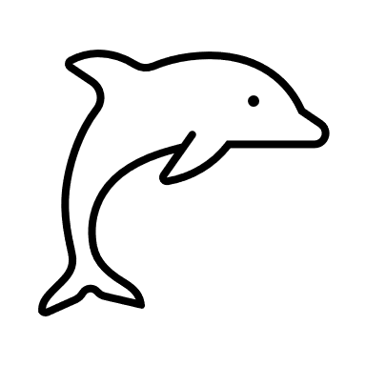
Swimming
with Dolphins

This is a great opportunity for families to meet and greet the dolphins and to learn about them.

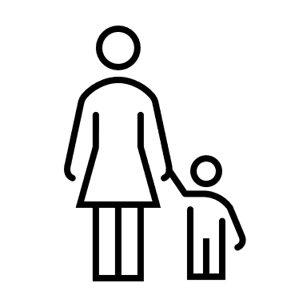
Mother & Toddler Morning
(feeding baby Animals on the Green)

Help Feed the Penquins
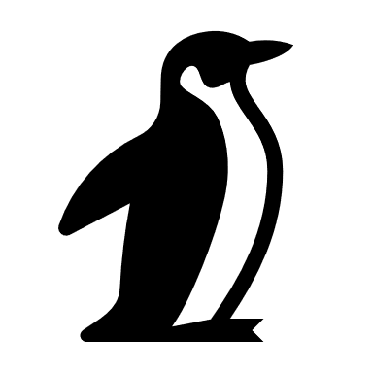
Children Needed to help Clean Animal Pens
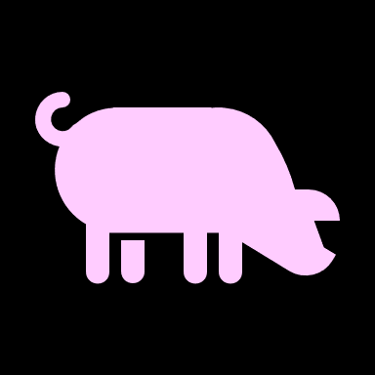

Free Ice Cream

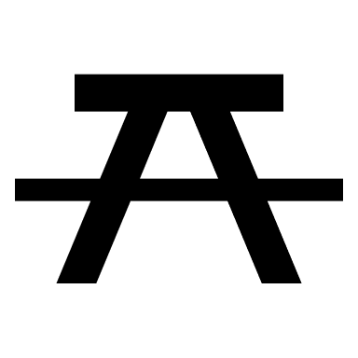
The Restaurant is situated beside Information Office
Outdoor Tables for Picnics on the Green
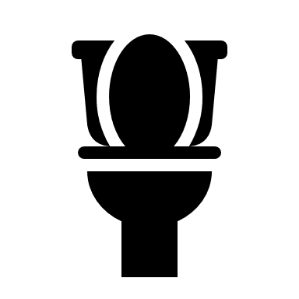
Toilets are situated at the Restaurant, the Picnic Area and at the Elephant Sanctuary
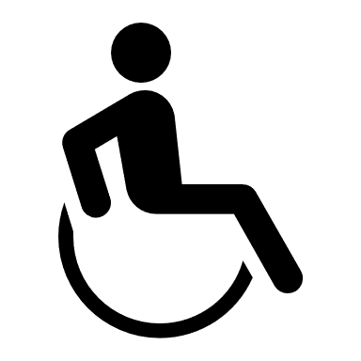
Disabled and Baby Changing facilities are incorporated with the Toilets
Remember to visit the Zoo Shop for Treats, Snacks, and Souvenirs

Thank you for Visiting With us…
Please Come Back

