- We have some of the worlds most amazing animal breeds.  - Our zoo has the biggest collection of fun activites and variety of animals  - The zoo has something for every age group.  - 50% of all money made at the zoo will go to helping all the animals worldwide that are in danger of deforestation and extinction.  - Our staff are very kinds and helpful and will always be willing to help, | 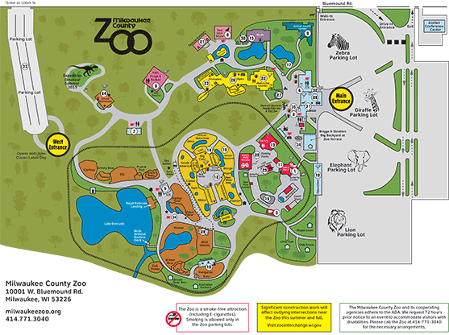  If you look carefully at our map you will see at the far end of the zoo we have a ziplining area where children from six up to twelve year olds can enjoy themselves.  How to get there  44 Penguin Road  Newcastle  BT71035  02887752591  www.hpszoo.co.uk  Ticket Option Summer Winter  Adult £15 £8  Child £10 £6  Infant (0-4) £4 Free  Family (5) £45 £30 | 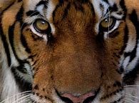  I love the bears  The best zoo ever!  Welcome  To  The Sir David Attenbrough  Childrens Zoo
Fun Activites Planned For 2020  The lake beside our chimps will have an exciting obstacle course all over the summer holidays.  Every day at 3pm we will b giving all our visitors free ice cream.  Now that our whale and dolphins are fully trained we will be doing a interactive show daily.  In our shark enclosure you can dive to the depths of the deep, dark blue exhibit in our shark cages.  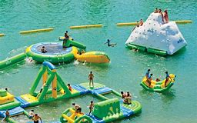  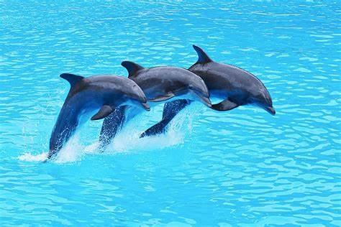 | Things to do  - Zip line  - Park  - Inflatable Park  - Daily Shows  - Help feed our giraffes and llamas  - Horse riding  - Beautiful picnic area where you will be likely to spot Perry our albino peacock.  - A small petting shed which contains rabbits, snakes. kittens, lizards and Guinee pigs.  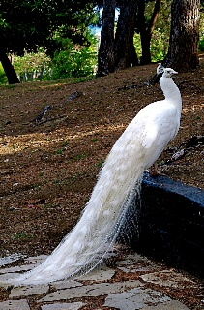 | Facilities  We have a restaurant with a play area so you will be able to stop for a break.  There is also a gift shop so you will be can remember your trip to our zoo.  Our toilet facilities are large and very modern décor. We have many baby changing and disabled toilets throughout the zoo.  We have a room with picnic tables and vending machines so if it rains you can enjoy your food indoors.

