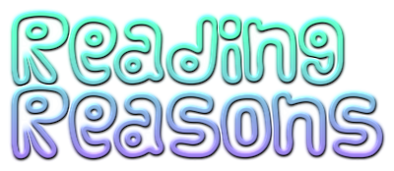

Some of our favourite authors are :
Enid Blyton , Liz Pichon , Roald Dahl, David Walliams,
Rachel Renee Russell, Andy Griffiths Terry Denton,
Jill Murphy, Michael Morpurgo and Cath Howe.
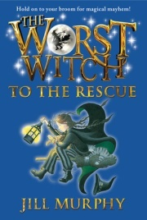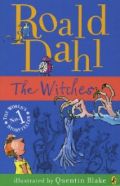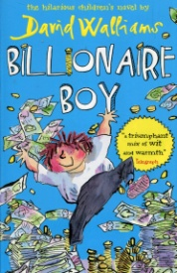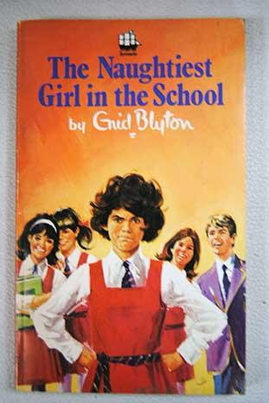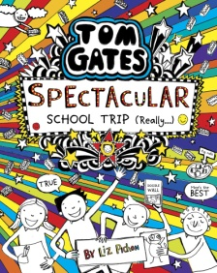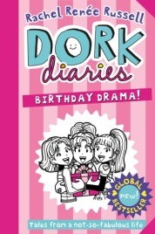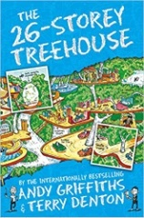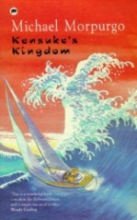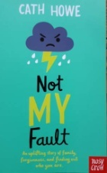

Why we like reading so much?
We love reading because, it is very interesting and, a great way to pass time. We also Love reading so much as some books have alot of drama which captives our minds.It is also a great pastime to keep boredom away.
Why Reading is important?
Reading is very impotrant as it expands your vocabulary.And in life you need to have good reading skills for doing exams and jobs.

By Ellie and Rebekah

